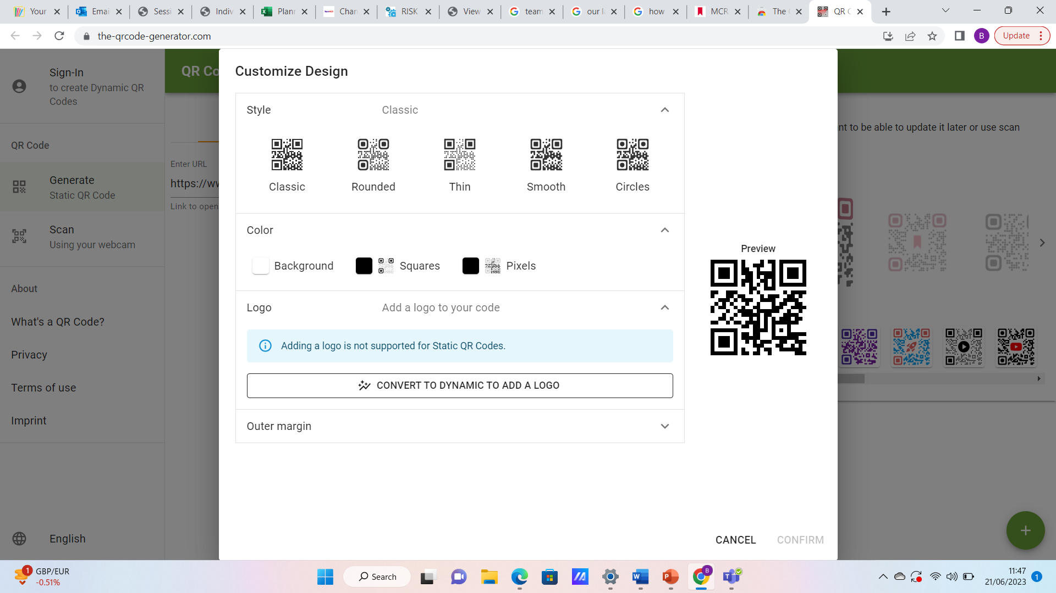

Our Lady’s Summer Holiday Programme

YOUNG PERSON REGISTRATION AND CONSENT FORM

To book your child’s place please complete Registration via the MCR Active Website.
Scan to Sign up via MCR Active
Or, you can complete this form and return to your school reception.

Or return to the contact at www.TeamMCR.co.uk

YOUNG PERSON’S DETAILS

FIRST NAME: ___________________________ SURNAME: ______________________________________

MALE / FEMALE: _______________________ DATE OF BIRTH: __________________________________
CURRENT YEAR AT SCHOOL (NB must be Year 4, 5, 6 or 7): ___________

SCHOOL ATTENDING: _____________________________________________________________
DOES YOUR CHILD RECEIVE FREE SCHOOL MEALS: _______________________
NB This programme is aimed at children receiving Free School Meals. Those not receiving FSM will be offered a space if spaces allow.

PARENT / CARER DETAILS: (These will be used to contact you in an emergency)

FIRST NAME: _________________________ SURNAME: _____________________________________

RELATIONSHIP TO CHILD: _______________________________________________________________
HOME ADDRESS: _______________________________________________________________
POSTCODE: _______________________________________________________________
HOME PHONE NUMBER: __________________________ MOBILE: _________________________________
EMAIL ADDRESS: _______________________________________________________________

Days my child will attend: (please tick):-
- WEEK 1: All 4 days  - Monday 24th July  - Tuesday 25th July  - Wednesday 26th July  - Thursday 27th July | - Week 2 : All 4 days  - Monday 31st July  - Tuesday 1st August  - Wednesday 2nd August  - Thursday 3rd August | - WEEK 3: All 4 days  - Monday 7th August  - Tuesday 8th August  - Wednesday 9th August  - Thursday 10th August

Please turn over…….

MEDICAL AND ALLERGY INFORMATION FOR YOUNG PERSON

Does your child:

- Have a disability, learning difficulty or special need? (Circle) YES / NO

MEDICAL AND ALLERGY INFORMATION FOR YOUNG PERSON (cont)

- Have any potential allergic reaction - general and/or to medication? (Circle) YES / NO

- Have any medical condition or take any medication of which we should be aware? (Circle) YES/NO

- Any other special requirements which we should be aware of?(Circle) YES / NO

If you have answered ‘YES’ to any question please give details below:
__________________________________________________________________________________
__________________________________________________________________________________
- Any food allergies or special dietary requirements?(Circle) YES / NO

If you have answered ‘YES’ to any question please give details below:
__________________________________________________________________________________
__________________________________________________________________________________

Photo Consent
- Photographs and/or video will be taken by TeamMCR. These will be used appropriately for TeamMCR publicity and information materials. Please tick the box if you consent to photographs and/or video of your child.

Please choose ONE of the two options:
- My child will be travelling on their own to and from the holiday scheme.
- My child is NOT allowed to travel alone and they will be picked up by myself or if this is not possible, the following person(s) will collect them:

Signed: Date:

Name (print): Relationship to Young Person:

