PE and sport premium monitoring and tracking form *2025/2026*

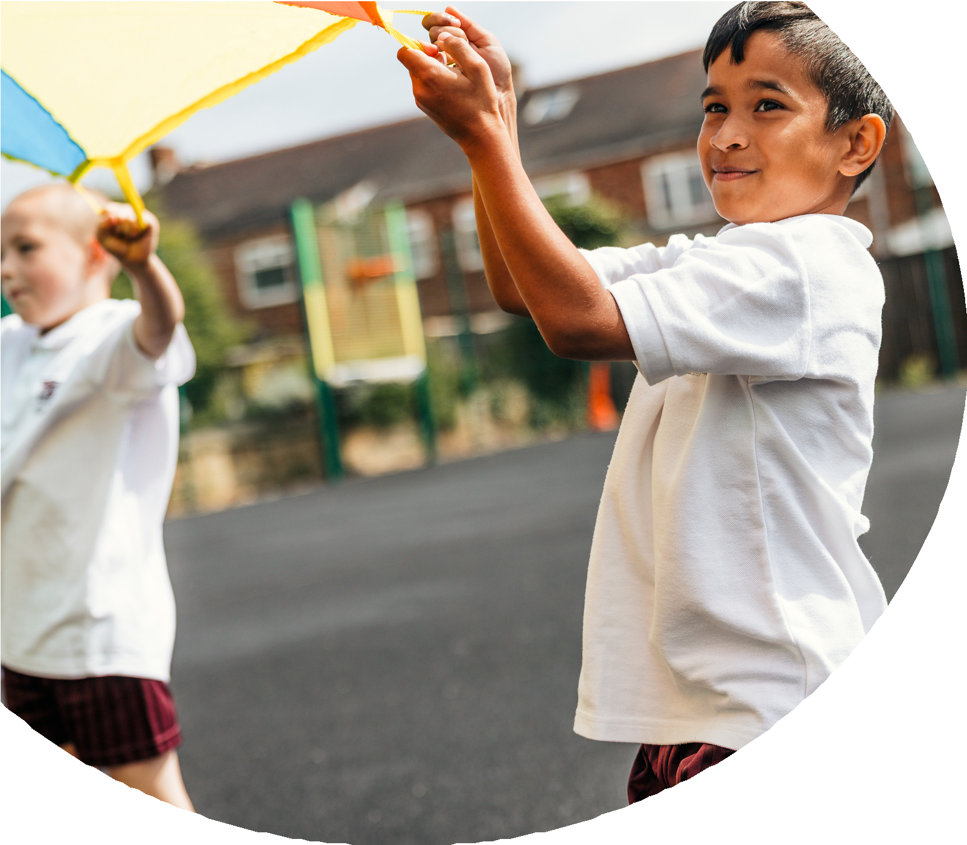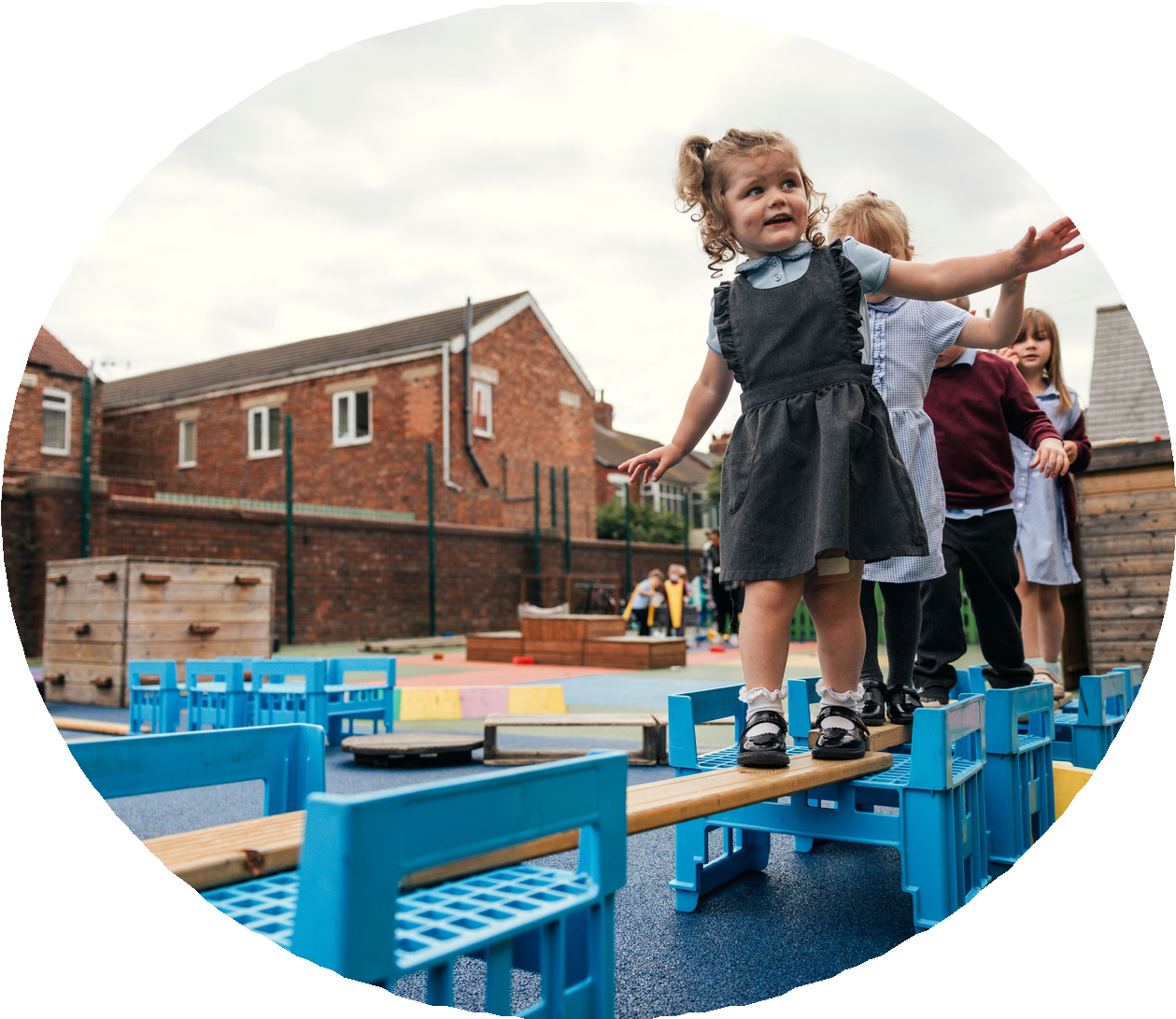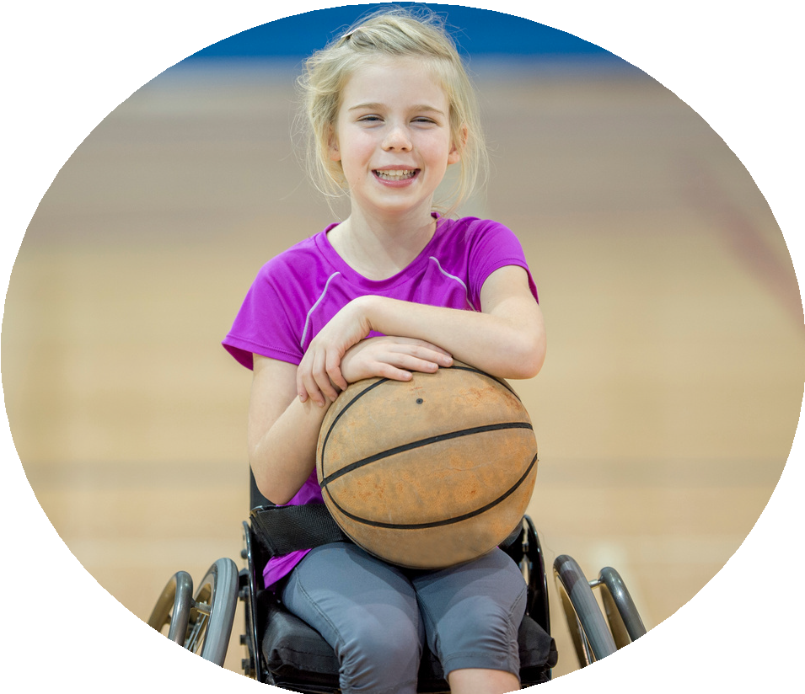

**Commissioned by**

**Created by**

# PE and sport premium monitoring and tracking form



* It is intended that this template should be used as preparation for the completion of the statutory DfE PE and sport premium digital expenditure reporting return. You can upload data (including swimming) from this template onto this platform once it becomes accessible.
* The template is a working document that you can amend and update during the year.
* Before you decide how you are going to use the funding for this academic year you should reflect and evaluate the impact of your use of you PE and sport premium funding in 2024/25.
* You should use your evaluation of last year’s funding to help you decide what to do this academic year, how you will do it, and what impact you expect it to have.
* All spending of the funding must conform with the terms outlined in the conditions of grant
* The summative digital expenditure reporting from June 2026 will continue to include swimming and water safety information. PE and sport premium funding can be used to provide top-up lessons, where necessary, to ensure pupils meet national curriculum swimming requirements
* To ensure funding is used effectively and based on your school’s needs; guidance and examples of best practice across schools can be found here.
* You must use the funding to make additional and sustainable improvements to the PE and sport in your school.
* You must develop and add to the PESSPA activities that your school already offers.

**Useful Links:**

* [Complete the PE and sport premium expenditure reporting return - GOV.UK](https://www.gov.uk/guidance/complete-the-pe-and-sport-premium-expenditure-reporting-return?utm_source=chatgpt.com)
* [PE and sport premium for primary schools - GOV.UK](https://www.gov.uk/guidance/pe-and-sport-premium-for-primary-schools)
* [PE and sport premium: conditions of grant 2024 to 2025 - GOV.UK](https://www.gov.uk/government/publications/pe-and-sport-premium-conditions-of-grant-2024-to-2025?utm_source=chatgpt.com)
* It is intended that this template should be used as preparation for the completion of the statutory DfE PE and sport premium digital expenditure reporting return. You can upload data (including swimming) from this template onto this platform once it becomes accessible.
* The template is a working document that you can amend and update during the year.
* Before you decide how you are going to use the funding for this academic year you should reflect and evaluate the impact of your use of you PE and sport premium funding in 2024/25.
* You should use your evaluation of last year’s funding to help you decide what to do this academic year, how you will do it, and what impact you expect it to have.
* All spending of the funding must conform with the terms outlined in the conditions of grant
* The summative digital expenditure reporting from June 2026 will continue to include swimming and water safety information. PE and sport premium funding can be used to provide top-up lessons, where necessary, to ensure pupils meet national curriculum swimming requirements
* To ensure funding is used effectively and based on your school’s needs; guidance and examples of best practice across schools can be found here.
* You must use the funding to make additional and sustainable improvements to the PE and sport in your school.
* You must develop and add to the PESSPA activities that your school already offers.

**Useful Links:**

[Complete the PE and sport premium expenditure reporting return - GOV.UK](https://www.gov.uk/guidance/complete-the-pe-and-sport-premium-expenditure-reporting-return?utm_source=chatgpt.com)

[PE and sport premium for primary schools - GOV.UK](https://www.gov.uk/guidance/pe-and-sport-premium-for-primary-schools)

[PE and sport premium: conditions of grant 2024 to 2025 - GOV.UK](https://www.gov.uk/government/publications/pe-and-sport-premium-conditions-of-grant-2024-to-2025?utm_source=chatgpt.com)

# Review of the last academic year (2024/2025)



|  |  |  |
| --- | --- | --- |
| [**Swimming and Water Safety**](https://www.swimming.org/schools/) | What went well? Supporting evidence? | **What didn't go well? Supporting evidence?** |
| **1.** Swim competently, confidently and proficiently over a distance of at least 25 metres |  |  |
| **2.** Use a range of strokes effectively (for example, front crawl, backstroke and breaststroke) |  |  |
| **3.** Perform safe self-rescue in different water-based situations |  |  |

* Take some time to reflect on your intent, implementation and impact from last academic year to celebrate your wins but to also think about improvements for the year ahead.
* You do not need to complete every box. Just record the information that is key to your school's priorities and areas of focus.

*Remember - Be clear about how you focussed spending on key groups such as SEND, girls and disadvantaged pupils.*

# Review of the last academic year (2024/2025)



|  |  |  |
| --- | --- | --- |
| **Key areas as outlined in PE and sport premium guidance** | What went well? Supporting evidence? | **What didn't go well? Supporting evidence?** |
| 1. Increasing confidence, knowledge and skills of all staff in teaching PE and sporting activities prioritising CPD and training where needed |  |  |
| **2.** Increasing engagement of all pupils in regular physical activity and sporting activities |  |  |
| **3.** Raising the profile of PE and sport across the school, to support whole school improvement |  |  |
| 4. Offer a broader and more equal experience of a range of sports and physical activities to all pupils and ensure equal access to sport for boys and girls |  |  |
| **5.** Increasing participation in competitive sport |  |  |



# Aims for the next academic year (2025/2026)



* Using your whole school priorities, school development plan and previous PE, school sport and physical activity data, set out your aims for the year ahead.
* Think about specific areas of need such as **inactive girls**, **SEND and** **disadvantaged pupils**
* Remember to also input your swimming data and reflections in the table located at the bottom of this page.
* Consider which of the 5 key areas improvements will be focussing on:

1. *Increasing confidence, knowledge and skills of all staff in teaching PE and sporting activities prioritising CPD and training where needed.*
2. *Increasing engagement of all pupils in regular physical activity and sporting activities*
3. *Raising the profile of PE and sport across the school, to support whole school improvement*
4. *Offer a broader and more equal experience of a range of sports and physical activities to all pupils and ensure equal access to sport for boys and girls*
5. *Increasing participation in competitive sport*

|  |  |  |
| --- | --- | --- |
| **Swimming and Water Safety** | Input data | **Reflections** |
| **1.** Swim competently, confidently and proficiently over a distance  of at least 25 metres |  |  |
| **2.** Use a range of strokes effectively  (for example, front crawl, backstroke and breaststroke) |  |  |
| **3.** Perform safe self-rescue in different water-based situations |  |  |



|  |  |  |  |
| --- | --- | --- | --- |
| Aim | Why? | Key area | Supporting evidence |
|  |  |  |  |
|  |  |  |  |
|  |  |  |  |
|  |  |  |  |
|  |  |  |  |
|  |  |  |  |

**Aims for the next academic year (2025/2026)**



# Plan, monitor and evaluate (2025/2026)



* Please aim to use this as a live working document through the year.
* Keep returning to this to evidence adaptations and progress made through the PESSPA opportunities you provide.
* There is no set number of objectives you must have.
* Make as many or as few as you see fit that will support your aims for the year ahead.
* Consider which of the 5 key areas improvements will be focussing on:

1. *Increasing confidence, knowledge and skills of all staff in teaching PE and sporting activities prioritising CPD and training where needed.*
2. *Increasing engagement of all pupils in regular physical activity and sporting activities*
3. *Raising the profile of PE and sport across the school, to support whole school improvement*
4. *Offer a broader and more equal experience of a range of sports and physical activities to all pupils and ensure equal access to sport for boys and girls*
5. *Increasing participation in competitive sport*

# Plan, monitor and evaluate (2025/2026)



**Example objective shown below is for reference purposes only:**

|  |  |  |  |  |
| --- | --- | --- | --- | --- |
|  | Intent – what is your objective? | **Implementation - How will you achieve this?** | **Impact - What do you hope to see?** | **Supporting evidence** |
| **Plan and monitor** | Develop lunchtime play provision to increase activity for least active groups. | Develop pupil leadership (training programme), Midday supervisor training, Staff CDP to develop their understanding of games and play, Range of equipment, Youth voice activities to understand pupils wants and needs Outdoor play provision such as OPAL | A confident and competent group of activity leaders that take initiative and create a more active and inclusive playground for all pupils. Midday supervisors and all staff leading a range of physical activities and joining in with movement daily to role model. A happier, more active playground that meets the needs of all pupils especially SEND and girls. | Youth voice data through half-termly surveys and interviews/group discussions with a variety of pupils (leaders, children participating and those that are less active at break times). Conduct regular observations of the playground to gauge activity levels of the least active children. Staff voice and feedback |
|  | What impact have you seen? | Are the improvements sustainable? How? | Supporting evidence | Approx. cost |
| **Evaluate** | Activity leaders are leading a broad range of activities and actively seeking children that are not engaged in physical activity during lunch times. Midday supervisors have grown in confidence and far more active and engaged in games with the children. Lunch times are more active with children having fun. Activity options have been tailored to suit the needs of SEND pupils through considerate choices of equipment and the types of games played. Girls are proving to be the hardest group to engage as some are still choosing not to be active | Continued training for activity leaders and bringing new leaders into the group to bring new ideas and expertise. More leaders will also mean more activities are able to be delivered. Continued training with midday supervisors. Establish lead midday supervisors to empower them and give them ownership. Continue to listen to SEND pupils and tailor activities to their needs and wants. Focus priorities on engaging girls. Work with least active girls to create activities that are meaningful and enjoyable for them. Do they want to be activity leaders for younger children to give them purpose and confidence? | 100 out of 100 activity leaders want to carry on with this role next year. 30 more children have enquired to joining the team. Meetings and the end of year survey have shown all leaders feel positive and enjoy making a difference for others. Interviews by random selection were conducted and 92% of pupils were either 'happy' or 'very happy' with the activities on offer at lunch time. End of year physical activity survey findings such as:- Am I involved with games at lunch time - 89% Yes- Do I enjoy lunch time? 97% Yes- Have I joined in with a game with the activity leaders? 100% Yes | Physical Resources - £1000CPD for staff - £500OPAL - £8000 |

**Your Objective:**



|  |  |  |  |  |
| --- | --- | --- | --- | --- |
|  | Intent – what is your objective? | **Implementation - How will you achieve this?** | **Impact - What do you hope to see?** | **Supporting evidence** |
| **Plan and monitor** |  |  |  |  |
|  | What impact have you seen? | Are the improvements sustainable? How? | Supporting evidence | Approx. cost |
| **Evaluate** |  |  |  |  |

**Your Objective:**

|  |  |  |  |  |
| --- | --- | --- | --- | --- |
|  | Intent – what is your objective? | **Implementation - How will you achieve this?** | **Impact - What do you hope to see?** | **Supporting evidence** |
| **Plan and monitor** |  |  |  |  |
|  | What impact have you seen? | Are the improvements sustainable? How? | Supporting evidence | Approx. cost |
| **Evaluate** |  |  |  |  |



**Your Objective:**

|  |  |  |  |  |
| --- | --- | --- | --- | --- |
|  | Intent – what is your objective? | **Implementation - How will you achieve this?** | **Impact - What do you hope to see?** | **Supporting evidence** |
| **Plan and monitor** |  |  |  |  |
|  | What impact have you seen? | Are the improvements sustainable? How? | Supporting evidence | Approx. cost |
| **Evaluate** |  |  |  |  |



**Your Objective:**

|  |  |  |  |  |
| --- | --- | --- | --- | --- |
|  | Intent – what is your objective? | **Implementation - How will you achieve this?** | **Impact - What do you hope to see?** | **Supporting evidence** |
| **Plan and monitor** |  |  |  |  |
|  | What impact have you seen? | Are the improvements sustainable? How? | Supporting evidence | Approx. cost |
| **Evaluate** |  |  |  |  |



**Your Objective:**

|  |  |  |  |  |
| --- | --- | --- | --- | --- |
|  | Intent – what is your objective? | **Implementation - How will you achieve this?** | **Impact - What do you hope to see?** | **Supporting evidence** |
| **Plan and monitor** |  |  |  |  |
|  | What impact have you seen? | Are the improvements sustainable? How? | Supporting evidence | Approx. cost |
| **Evaluate** |  |  |  |  |



**This page has been left blank for any notes or supporting information.**